IoT Based Smart Agriculture Monitoring System

Submitted by

Rakibul Hasan Emon

ID: 1915002532

Sumon Bepari

ID: 1915002516

A project report submitted in partial fulfillment of the requirements for the degree of Bachelor of Science in Computer Science and Engineering from City University



DEPARTMENT OF COMPUTER SCIENCE AND ENGINEERING

CITY UNIVERSITY, DHAKA, BANGLADESH

FEBRUARY 2023

IoT Based Smart Agriculture Monitoring System

Submitted by

Rakibul Hasan Emon

ID: 1915002532

Sumon Bepari

ID: 1915002516

A project report submitted in partial fulfillment of the requirements for the degree of Bachelor of Science in Computer Science and Engineering from City University



DEPARTMENT OF COMPUTER SCIENCE AND ENGINEERING

CITY UNIVERSITY, DHAKA, BANGLADESH

FEBRUARY 2023

**DECLARATION**

This is to certify that the project titled “**IoT Based Smart Agriculture Monitoring System**” is the result of our study in partial fulfillment of the B.Sc. Engineering degree under the supervision of Ayesha Siddika, Assistant Professor, Department of Computer Science and Engineering (CSE), City University, Dhaka, Bangladesh. It is also hereby declared that this project or any part of it has not been submitted elsewhere for the award of any degree.

|  |  |
| --- | --- |
| Signature of Supervisor  Ayesha Siddika  Assistant Professor  Dept. of Computer Science and Engineering, City University  Dhaka, Bangladesh  Signature of Author’s  Rakibul Hasan Emon  ID: 1915002532  Dept. of Computer Science and Engineering, City University  Dhaka, Bangladesh  Sumon Bepari  ID: 1915002516  Dept. of Computer Science and Engineering, City University  Dhaka, Bangladesh  ii |  |

**ACKNOWLEDGEMENT**

First, we would like to say heartiest thanks to almighty “ALLAH” for giving us the strength to finish the project as a part of our partial fulfillment for the requirements for the Degree of B. Sc. in Computer Science and Engineering. We would like to express our gratitude and appreciation to our supervisor Ayesha Siddika, Assistant Professor , Department of Computer Science and Engineering of City University for the guidance and enthusiasm extended throughout the progress of this work. We would like to say Special thanks to our head of the department Md. Safaet Hossain, Associate Professor & Head, Department of Computer Science and Engineering of City University for his precious advises, fruitful suggestions and coordination. We would like to express our heartiest gratitude to Prof. Dr. Engr. Md. Humaun Kabir, Dean, Faculty of Science & Engineering, City University for allowing us to do the projects. We are also grateful to all the faculties of the Department of Computer Science and Engineering of City University, Bangladesh for giving us the opportunity to complete the work and necessary support during the period. This thesis work would not have been possible without the encouragement, logical help and advice from our friends. We are grateful to them. Finally, we must acknowledge with due respect the constant support and patience of our parents.

iii

**ABSTRACT**

Agriculture is the primary occupation in our country for ages. Agriculture plays vital role in the development of agricultural country. Agricultural problems have always hindered the development of the country. So to overcome this problem we go for smart agriculture techniques using IoT. That plays a key role in smart agriculture. The main advantage of IoT is to monitor the agriculture by using the wireless sensor networks and collect the live data from different sensors which are deployed at various nodes and send by wireless protocol. By using IoT system the smart agriculture is powered by NodeMCU. It includes the Temperature, Humidity, Soil Moisture, Soil Temperature, LED and Water Pump. The soil moisture sensor are used to sense the soil moisture, if the soil moisture goes below a certain level, then it's mean soil need water. LED will be turned on when we need. The temperature level based on type of crops cultivated can also be adjusted. Overall farmers will enable to increase the yield and quality of products using this technology.

iv

**TABLE OF CONTENTS**

|  |  |  |  |  |  |  |
| --- | --- | --- | --- | --- | --- | --- |
| **Name of The Content** | | | | | | **Page** |
| Declaration | | | | | | ii |
| Acknowledgement | | | | | | iii |
| Abstract | | | | | | iv |
| List of Figures | | | | | | vii |
| List of Tables | | | | | | viii |
|  | | | | | |  |
| **Chapter 1: Introduction** | | | | | | **1** |
| 1.1 | | Introduction | | | | 1 |
| 1.2 | | Objectives of the Research Project | | | | 2 |
| 1.3 | | Features of the Research Project | | | | 2 |
| **Chapter 2: Literature Review** | | | | | | **3** |
| 2.1 | | Literature Review | | | | 3 |
| 2.2 | | Background Study | | | | 4-5 |
| 2.3 | | Comparison Features with the existing system | | | | 6 |
| **Chapter 3: Methodology/Experimental Design** | | | | | | **7** |
| 3.1 Methodology | | | | | | 7-8 |
| 3.2 | | Required Components and Software | | | | 8 |
| 3.3 | | Description of the Components | | | | 8 |
|  | | 3.3.1 | | NodeMCU | | 8 |
|  | | 3.3.2 | | Soil Moisture Sensor | | 9 |
|  | | 3.3.3 | | DHT11 Sensor | | 10 |
|  | | 3.3.4 | | DS18B20 Temperature Sensor | | 11 |
|  | | 3.3.5 | | Display | | 12 |
|  | | 3.3.6 | | Water Pump | | 12 |
|  | | 3.3.7 | | Relay  v | | 13 |
|  | | 3.3.8 | | Wire | | 13 |
|  | | 3.3.9 | | Breadboard | | 14 |
|  | | 3.3.10 | | LED | | 14 |
|  | | 3.3.11 | | Power Supply | | 15 |
| 3.4 | | Description of the Software | | | | 15 |
|  | 3.4.1 | | Arduino IDE | | 15 | | | |
|  | 3.4.2 | | About Blynk Server | | 16 | | | |
| 3.5 | Block diagram of Proposed System 17 | | | | | | |
| 3.6 | Circuit Diagram of Proposed System | | | | 18 | | | | | |
| 3.7 | Activity Diagram of Proposed System 19 | | | | | | | | |  | |
| 3.8 | Use Case of Proposed System | | | | 20 | | | |
| 3.9 | Hardware Result | | | | 21-22 | | | |
| 3.10 | Programming/Code | | | | 23-27 | | | |
| **Chapter 4: Results and Discussion** | | | | | **28** | | | |
| 4.1 | Result and Discussion | | | | 28-30 | | | |
| 4.2 | Budget | | | | 31 | | | |
| **Chapter 5: Conclusion and Recommendations** | | | | | **32** | | | |
| 5.1 | Conclusion and Recommendations | | | | 32 | | | |
| 5.2 | Future Work | | | | 32 | | | |
| 5.3 Limitation | | | | | 33 | | | |
| **References** | | | | | **34** | | | |

vi

**List of Figure**

Fig 3.3.1: NodeMCU (ESP8266) 9

Fig 3.3.2: Soil Moisture Sensor 10

Fig 3.3.3: Temperature and Humidity Sensor - DHT11 10

Fig 3.3.4: DS18B20 Temperature Sensor 11

Fig 3.3.5: LCD display 12

Fig 3.3.6: Water pump 12

Fig 3.3.7: Relay Module 13

Fig 3.3.8: Wire 13

Fig 3.3.9: Breadboard 14

Fig 3.3.10: LED 14

Fig 3.3.11: Power Supply 15

Fig 3.4.2.1 Blynk Home Page 16

Fig 3.4.2.1: Blynk Auth Token 16

Fig 3.5: Block Diagram 17

Fig 3.6: Circuit Diagram 18

Fig 3.7: Activity Diagram 19

Fig 3.8: Use Case Diagram 20

Fig 3. 9.1: Hardware Result 21

Fig 3. 9.2: Hardware Result 21

Fig 3. 9.3: Hardware Result 22

Fig 4.1.1: Temperature Result 28

Fig 4.1.2: Humidity Result 29

Fig 4.1.3: Soil Moisture Result 29

Fig 4.1.4: Soil Temperature 30

Fig 4.1.5: Water Pump and LED Button 30

Fig 4.1.6: Value shows on display 30

vii

vi

**LIST OF TABLES**

|  |  |  |
| --- | --- | --- |
| **Table No** | **Table Contain** | **Page No** |
|  |  |  |

Table 2.3:Comparison Features with the existing system 6

Table 4.2:Budget 31

viii

CHAPTER 1

INTRODUCTION

* 1. **Introduction**

Agriculture is the backbone of Bangladesh economy. Close to 50 percent of Bangladesh's population is primarily employed in agriculture, with more than 70 percent of its land dedicated to growing crops. Agriculture is the largest employment sector in our country, making up 14.2 percent of GDP . The rise in population is proportional to the increase in agricultural production. Basically, Agricultural production depends upon the seasonal situation .Unfortunately, many farmers still use the traditional methods of farming which results in low yielding of crops and fruits .They won't worry about the temperature, water level and simply climate conditions that are terrible to farmers. So to overcome this problem we go for smart agriculture techniques using IoT. In IoT-based smart farming, a system is built for monitoring the crop field with the help of of sensors like humidity, temperature, soil moisture, etc. The user can monitor the field conditions from anywhere. IoT-based smart farming is highly efficient when compared with the conventional approach. In this smart agriculture using IoT system powered by NodeMCU consists of a DHT11 sensor, Moisture sensor, DS18B20 Sensor Probe, LED, Water Pump, . When the IoT-based agriculture monitoring system starts, it checks the Soil moisture, temperature, humidity, and soil temperature .Then sends this data to the IoT cloud for live monitoring .Here we can use Blynk Server to analyze live data on the cloud. By doing this we can reduce a lot of manual work in the field of agriculture using IoT. Like if the soil moisture goes below a certain level, then we will start the water pump by using Iot. Hence this project is about to developing a smart agriculture monitors system using IoT and given to the farmers for increase the yield and quality of products using this technology.

* 1. **Objectives of the Research Project**
* Design low cost IoT based smart agriculture monitoring system.
* Proper use of water.
* Monitoring field conditions and plant condition from anywhere.
* Reduce manual work in the field of agriculture using automation.
  1. **Features of the Research Project**
* Measure Temperature, Soil Temperature, Humidity and Soil Moisture.
* See the value in the Display.
* IoT based water pump control.
* IoT based LED light control.
* Collect real time data.

CHAPTER 2

LITERATURE REVIEW

**2.1 Literature Review**

It aims at making agriculture smart using automation and IoT technologies. The highlighting features are smart GPS based remote controlled robot to perform tasks like weeding, spraying, moisture sensing, human detection and keeping vigilance [1].It proposes a low cost and efficient wireless sensor network technique to acquire the soil moisture and temperature from various location of farm and as per the need of crop controller to take the decision whether the irrigation is enabled or not[2].As the world is trending into new technologies and implementations it is a necessary goal to trend up in agriculture also. Many researches are done in the field of agriculture. Most projects signify the use of wireless sensor network collect data from different sensors deployed at various nodes and send it through the wireless protocol. The collected data provide the information about the various environmental factors. Monitoring the environmental factors is not the complete solution to increase the yield of crops. There are number of other factors that decrease the productivity to a greater extent. Hence automation must be implemented in agriculture to overcome these problems[3].The system will determine the parameters that are monitored in irrigation systems regarding water quantity and quality, soil characteristics, and fertilizer usage and provide an overview of the most utilized nodes and wireless technologies employed to implement WSN and IoT based smart irrigation systems[4].Farming is still development on techniques which were evolved hundreds of years ago and doesn’t take care of conservation of resources. My project is to give cheap, reliable, cost efficient and easy to use technology which would help in conservation of resources such as water and also in automating farms. We proposed use of temperature, moisture, humidity and pH sensor at suitable locations for monitoring of crops [5].IOT modernization helps in get together data on conditions like atmosphere, protection, temperature and productivity of soil, Harvest online assessment enables disclosure of wild plant, level of water, cultivation area, animal break in to the field, trim turn of events, agriculture[6].The propose of this report is to IoT based Smart Farming System assisting farmers in getting Live Data (Temperature, Soil Moisture) for efficient environment monitoring which will enable them to increase their overall yield and quality of products [7].

**2.2 Background Study**

Existing Work-01:

Title: IoT based Smart Agriculture.

OVERVIEW:

The project aims at making agriculture smart using automation and IoT technologies. The highlighting features of this project includes smart GPS based remote controlled robot to perform tasks like weeding, spraying, moisture sensing, bird and animal scaring, keeping vigilance, etc. Secondly it includes smart irrigation with smart control and intelligent decision making based on accurate real time field data. Thirdly, smart warehouse management which includes temperature maintenance, humidity maintenance and theft detection in the warehouse. Controlling of all these operations will be through any remote smart device or computer connected to Internet and the operations will be performed by interfacing sensors, Wi-Fi or ZigBee modules, camera and actuators with micro-controller and raspberry pi. [1]

Existing Work-02:

Title: Smart Farming System Using Sensors for Agricultural Task Automation.

OVERVIEW:

In this paper, they have proposed a novel methodology for smart farming by linking a smart sensing system and smart irrigator system through wireless communication technology. Our system focuses on the measurement of physical parameters such as soil moisture content, nutrient content, and pH of the soil that plays a vital role in farming activities. Based on the essential physical and chemical parameters of the soil measured, the required quantity of green manure, compost, and water is splashed on the crops using a smart irrigator, which is mounted on a movable overhead crane system. The detailed modeling and control strategies of a smart irrigator and smart farming system are demonstrated in this paper. [2]

Existing Work-03:

Title: IoT Based Smart Agriculture Monitoring System.

OVERVIEW:

This system starts to check the humidity and moisture level. The sensors are used to sense the level of water and if the level is below the range then the system automatically stars watering. According to the change in temperature level the sensor does its job. IoT also shows the information of humidity, moisture level by including date and time. The temperature level based on type of crops cultivated can also be adjusted. [4]

Existing Work-04:

Title: Iot Based Smart Agriculture.

OVERVIEW:

We proposed use of temperature, moisture, humidity and pH sensor at suitable locations for monitoring of crops. The sensing system is based on a feedback control mechanism with a centralized control unit which regulates the flow of water on to the field in the real time based on the instantaneous temperature, moisture, humidity and pH values. Thus by providing right amount of water we would increase the efficiency of the farm. As per the need of crop controller take the decision to make irrigation ON or OFF using arduino NodeMCU . [5]

Existing Work-05:

Title: A Mini Project Report On IoT-Based SMART FARMING SYSTEM

OVERVIEW:

The aim of this Project is to propose IoT based Smart Farming System assisting farmers in getting Live Data (Temperature, Soil Moisture) for efficient environment monitoring which will enable them to increase their overall yield and quality of products. The IoT based Smart Farming System being proposed via this report is integrated with Arduino Technology mixed with different Sensors and a Wifi module producing live data feed that can be obtained online from Thingsspeak.com. The product being proposed is tested on Live Agriculture Fields giving high accuracy over 98% in data feeds. [7]

**2.3 Comparison Features with the existing system**

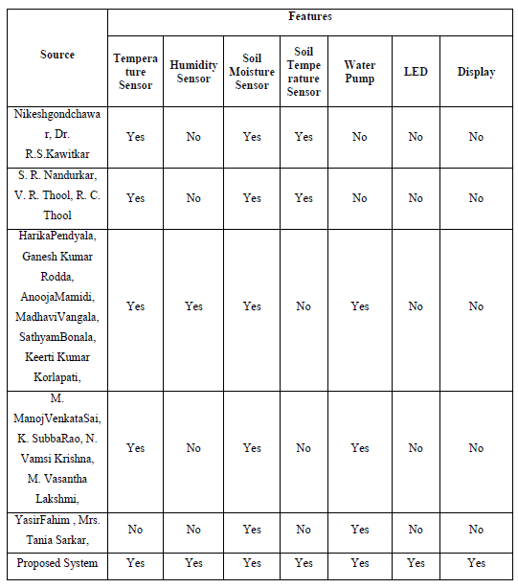

Table 2.3:Comparison Features with the existing system

CHAPTER 3

METHODOLOGY

**3.1. Methodology**

First we Write the code in Arduino IDE then upload the code to NodeMCU board. Based on the behavior of sensors NodeMCU transfer the data to the cloud server called Blynk server. Then we connect all the hardware components with NodeMCU. The components are Soil Moisture sensor, Temperature and humidity sensor, DS18B20 Temperature Sensor, Realy, LED, Water Pump and Display. Then once the data is uploaded to NodeMCU hardware and connected to Arduino IDE, The project starts to work. Then based on the behavior of the Sensor, NodeMCU board starts working, following are the functionalities of all the sensor once the board is activated:- Temperature and humidity sensor: initially Once the board is activated, instantly it will start showing the exact temperature and humidity in that particular place. Hence this sensor helps in detecting the temperature and humidity. Soil Moisture sensor: This sensor helps in providing the exact moisture content in the soil. Soil moisture is basically the content of water present in the soil. DS18B20 Temperature Sensor: This is a waterproofed version of the DS18B20 Temperature sensor. Handy for when you need to measure something far away, or in wet conditions. Then Temperature, Humidity, Soil Temperature and Soil Moisture will be shown on the LCD display. We can easily turn on or off the Water Pump and LED light using the cloud server.When the system connects with Blynk server through over the internet then we will also see the same value in the Blynk server account from anywhere.

Overall Process:

Step 1: Start The Process

Step 2: Connected To Wifi

Step 3: Measure the Soil Moisture value.

Step 4: Measure Temperature and Humidity of atmosphere.

Step 5: Measure the soil Temperature.

Step 7: Soil Moisture, Temperature and Humidity, Soil Temperature value shows on the LCD display.

Step 8: Send Data to Blynk server.

Step 9: Shows the system status on the channel name is "IoT Based Smart Agriculture Monitoring System" on the Blynk server.

Step 10: Repeat Step 3, 4, 5,6,7,8 &9 until the Process Stop

Step 13: Stop

**3.2 Required Components and Software**

**Hardware requirements for developing the system:**

* NodeMCU
* Soil Moisture Sensor
* DHT11 Sensor
* DS18B20 Temperature Sensor
* Display
* Water Pump
* Relay
* Wire
* Breadboard
* LED
* Power Supply

**Development Requirements:**

To develop the project must a **Smart Phone** is needed. Below the minimum requirements given:

* IDE: Arduino,
* C/C++ programming
* Internet Connection

**3.3 Description of Components**

**3.3.1 NodeMCU**

The NodeMCU (ESP8266) is a microcontroller with an inbuilt Wi-Fi module. The total pins on this device are 30 out of which 17 are GPIO (General Purpose Input/output) pins which are connected to various sensors to receive data from the sensors and send output data to the connected devices. The NodeMCU has 128KB of RAM and 4MB flash memory storage to store programs and data. The code is dumped into the NodeMCU through USB and is stored in it. Whenever the NodeMCU receives input data from the sensors, it crosschecks the data received and stores the received data. Depending on the data received it sends a pulse to the Relay Module which in-turn acts as a switch to on or off the pump. The operating frequency of the NodeMCU ranges from 80 to 160 MHZ and the operating voltage of this device range from 3 to 3.6V. The Wi-Fi module presents in the NodeMCU range from 46 (indoors) to 92 (Outdoors) Meters.

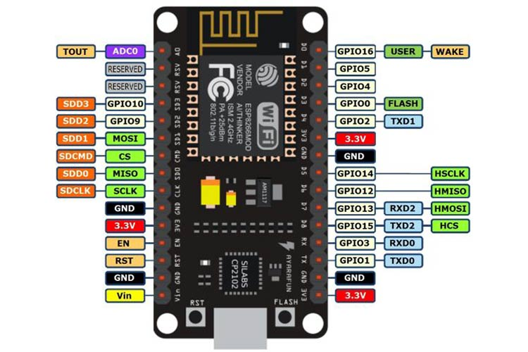

Fig 3.3.1: NodeMCU (ESP8266)

**3.3.2 Soil Moisture Sensor**

Soil moisture sensor measures the water content in soil. The sensor has both the analog and the digital output. The digital output is fixed and the analog output threshold can be varied. The sensor has two large exposed pads which functions as probes for the sensor. It works on the principle of open and short circuit. The output is high or low indicated by the LED. When the soil is dry, the current will not pass through it and so it will act as open circuit. Hence the output is said to be maximum. When the soil is wet, the current will pass from one terminal to the other and the circuit is said to be short and the output will be zero. Here, It is used to sense the moisture in field and transfer it to microcontroller in order to take controlling action of switching water pump ON/OFF.



Fig 3.3.2: Soil Moisture Sensor

**3.3.3 DHT11 Sensor**

Temperature and Humidity Sensor (DHT11) is used to monitor temperature and humidity of the atmosphere. The DHT11 is a basic, low-cost digital temperature and humidity sensor. It gives out digital value and hence there is no need to use conversion algorithm at ADC of the microcontroller and hence we can give its output directly to data pin instead of ADC. It has a capacitive sensor for measuring humidity. DHT11 sensor can measure a humidity value in the range of 20-90% of relative humidity (RH) and Temperature in the range of 0-50c.

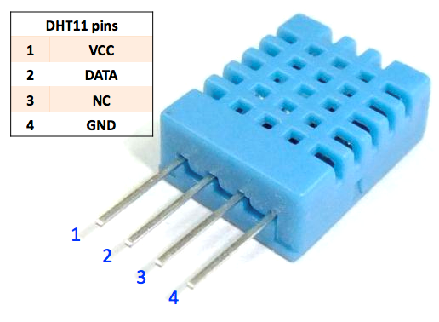

Fig 3.3.3: Temperature and Humidity Sensor - DHT11

**3.3.4 DS18B20 Temperature Sensor**

This is a waterproofed version of the DS18B20 Temperature sensor. Handy for when you need to measure something far away, or in wet conditions. While the sensor is good up to 125ºC the cable is jacketed in PVC so we suggest keeping it under 100ºC. Because they are digital, you don't get any signal degradation even over long distances. The DS18B20 provides 9 to 12-bit (configurable) temperature readings over a 1-Wire interface, so that only one wire (and ground) needs to be connected from a central microprocessor. Usable with 3.0-5.5V systems.

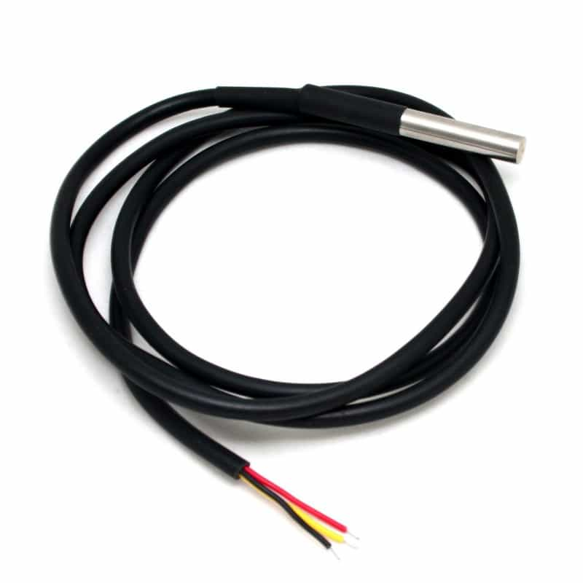

Fig 3.3.4: DS18B20 Temperature Sensor

**3.3.5 Display**

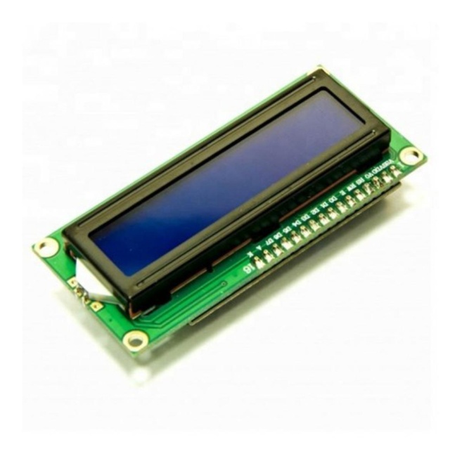LCD (Liquid Crystal Display) is a type of flat panel display which uses liquid crystals in its primary form of operation. LEDs have a large and varying set of use cases for consumers and businesses, as they can be commonly found in smart phones, televisions, computer monitors and instrument panels. Temperature, Humidity and Soil Moisture, Soil Temperature will be shown on the LCD display.

Fig 3.3.5: LCD display

**3.3.6 Water Pump**

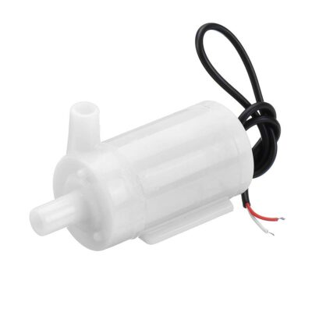This DC 5V Mini Submersible Water Pump is a low cost, small size Submersible Pump Motor which can be operated from a 5V power supply. It can take up to 120 liters per hour with a very low current consumption of 220mA. Just connect the tube pipe to the motor outlet, submerge it in water, and power it.

Fig 3.3.6: Water pump

**3.3.7 Relay**

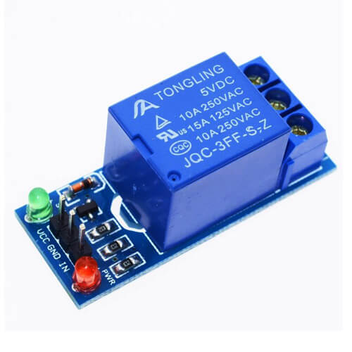A Relay is a simple electromechanical switch. While we use normal switches to close or open a circuit manually, a Relay is also a switch that connects or disconnects two circuits. But instead of a manual operation, a relay uses an electrical signal to control an electromagnet, which in turn connects or disconnects another circuit. Relay is used to turn on the water pump in order to maintain the moisture level of the soil.

## Fig 3.3.7: Relay Module

**3.3.8 Wire**

These wires are actually electrical wires which basically used for the interconnection of the components in the breadboard without soldering.

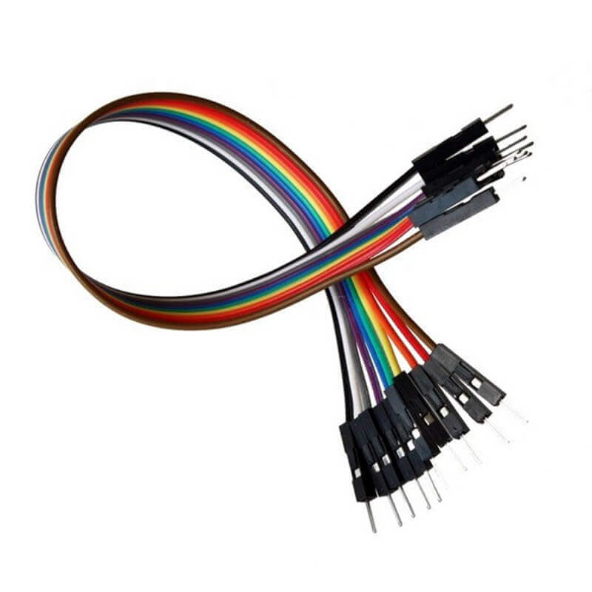

Fig 3.3.8: Wire

**3.3.9 Breadboard**

To build temporary circuit this board is used. Here the component replacement, remove, builds are so easy and time convenient which makes it more useful. By putting the terminal of the wires into the whole making connection among the digital components need to be interconnected.

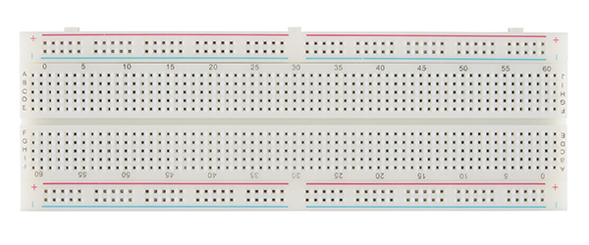

Fig 3.3.9: Breadboard

**3.3.10 LED**

LED is a semiconductor device. When current passes through it, it can emit light. It is actually a diode, which is called light emitting diode. We use it as light purpose. The light turns on or turns off using IoT button when we need.

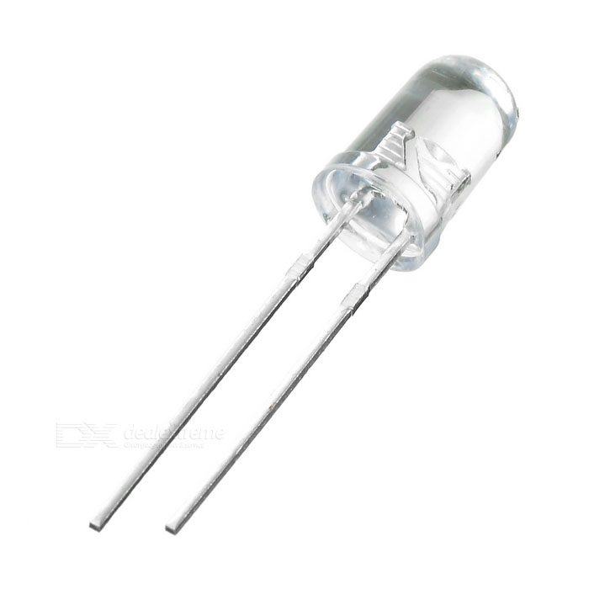

Fig 3.3.10: LED

**3.3.11 Power Supply**

We supply 5volt DC power for this system by using USB cable.

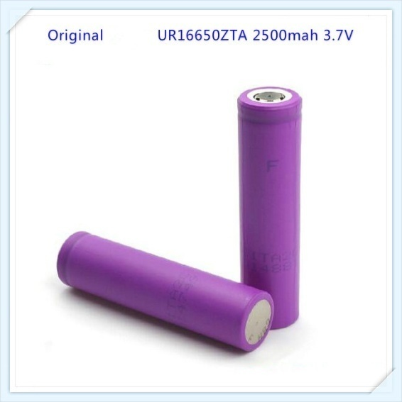

Fig 3.3.11: Power Supply

* 1. **Description of Software**
     1. **Arduino IDE**

The Arduino Integrated Development Environment (IDE) is a cross-platform application in which the functions are written in C and C++ languages. It is used to write and dump the written programs to Arduino compatible boards with the help of third party cores and other vendor development boards.

**3.4.2 About Blynk Server**

Blynk is an IoT analytics platform which is used to aggregate, visualize, and analyze live data streams in the cloud. When the data is sent to Blynk from the devices, it creates instant visualization of live data and sends an alert. Blynk dashboard store data sent to them from apps or devices.

Fig 3.4.2.1: Blynk Home Page

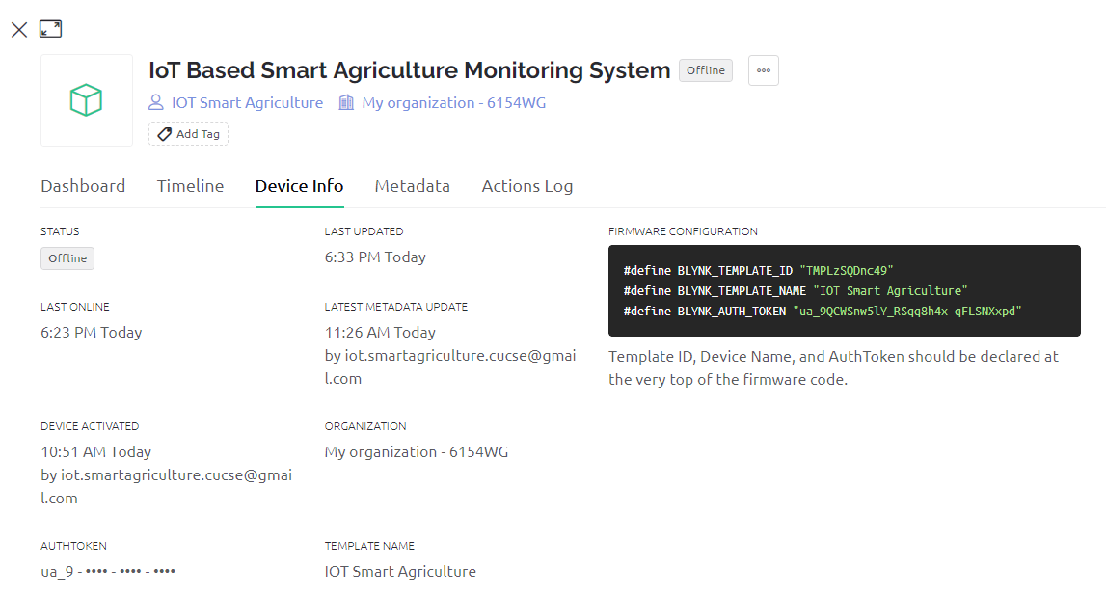We have created our dashboard as “IoT Based Smart Agriculture Monitoring System” with four fields Temperature, Humidity, Moisture and soil temperature and two button fields. which represents the values that are taken from sensors in graphical and Numeric format. Blynk Auth Token enables you to write data to a dashboard.

Fig 3.4.2.1: Blynk Auth Token

**3.5 Block Diagram**

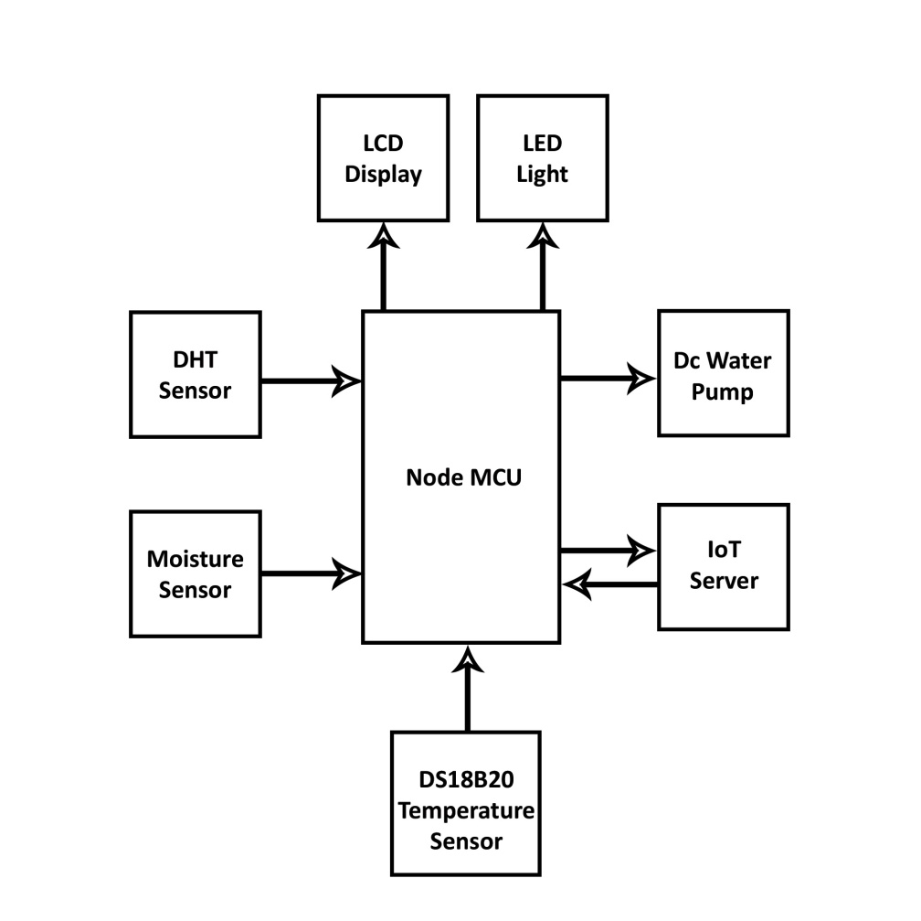

Fig 3.5: Block Diagram

**3.6 Circuit Diagram**

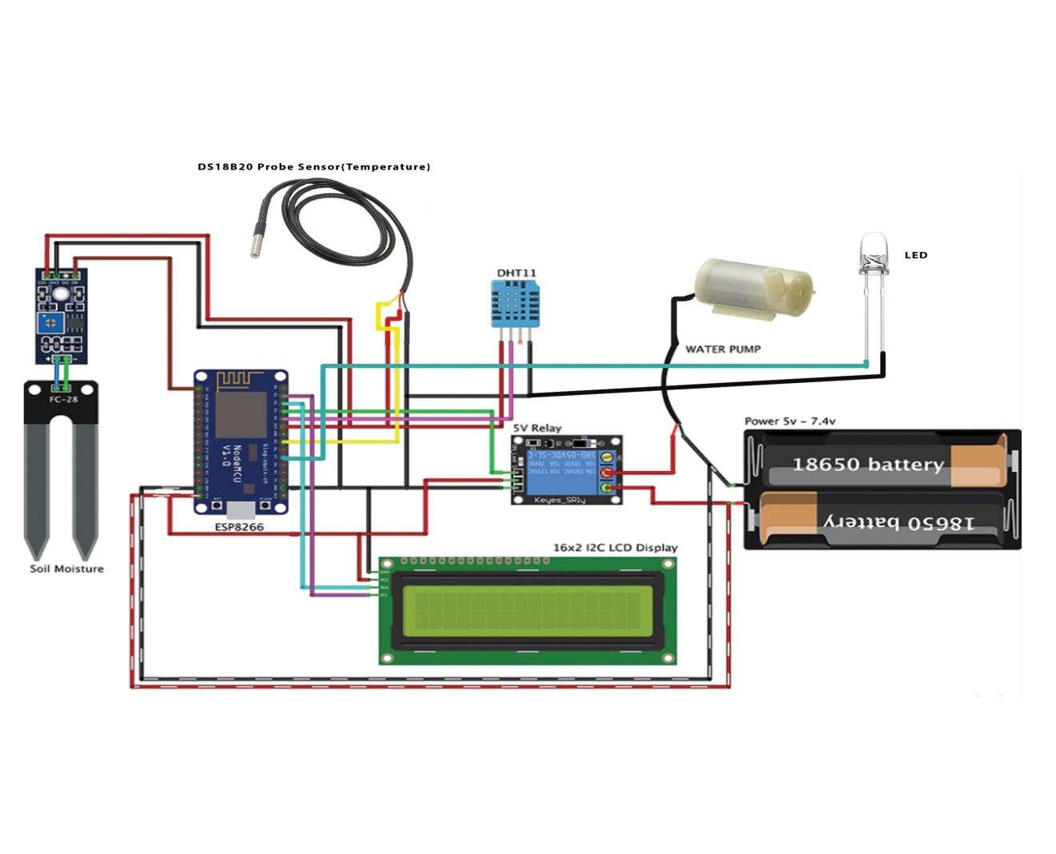

Fig 3.6: Circuit Diagram

**3.7 Activity Diagram**

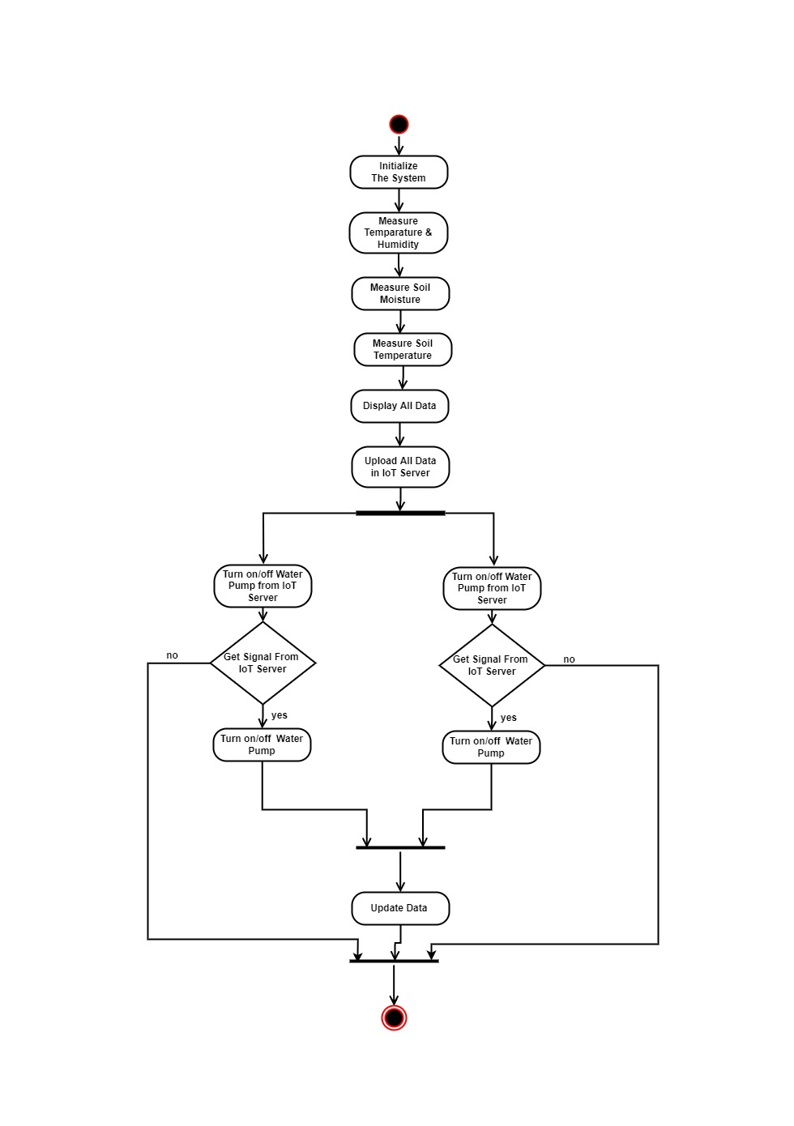

Fig 3.7: Activity Diagram

**3.8 Use Case Diagram**

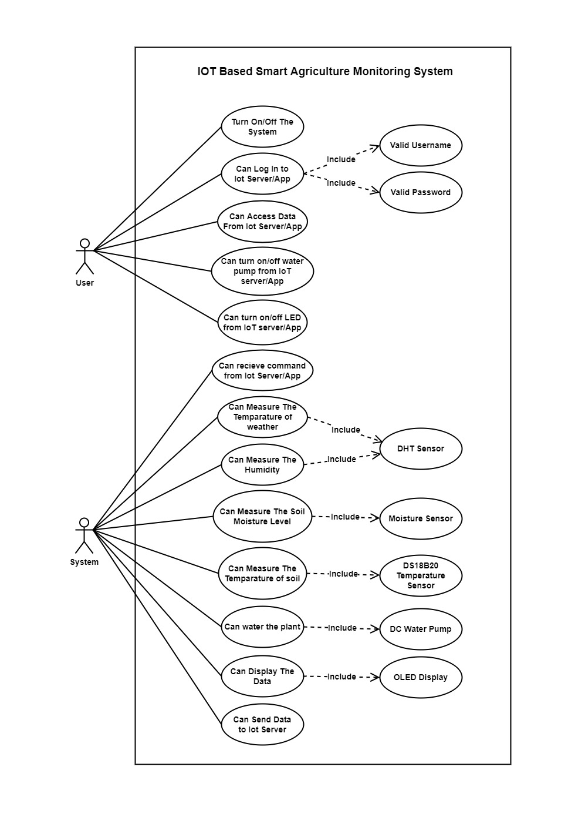

Fig 3.8: Use Case Diagram

**3.9 Hardware Result**

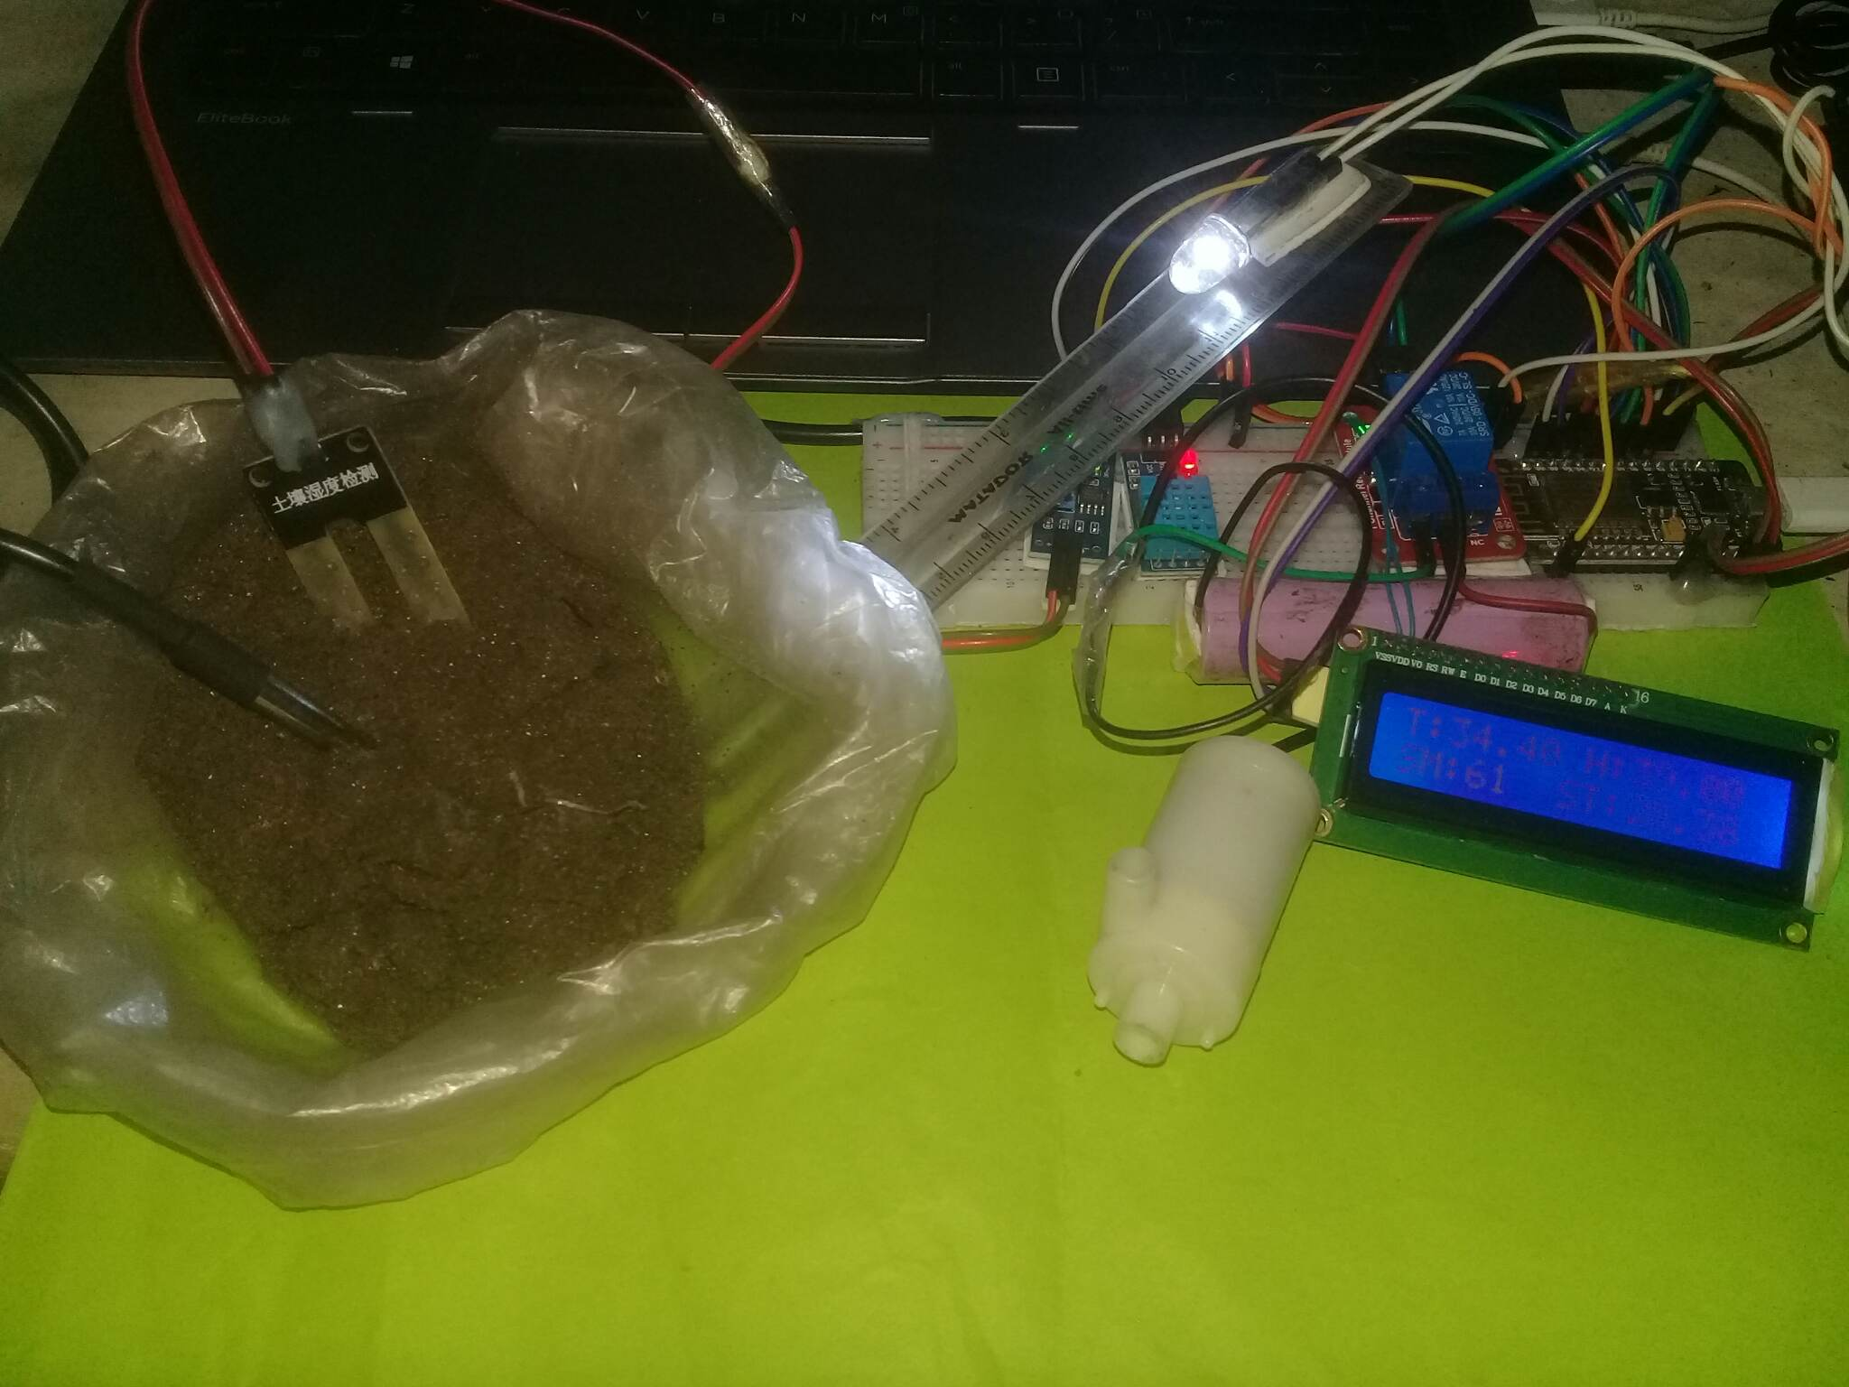

Fig 3. 9.1: Hardware Result

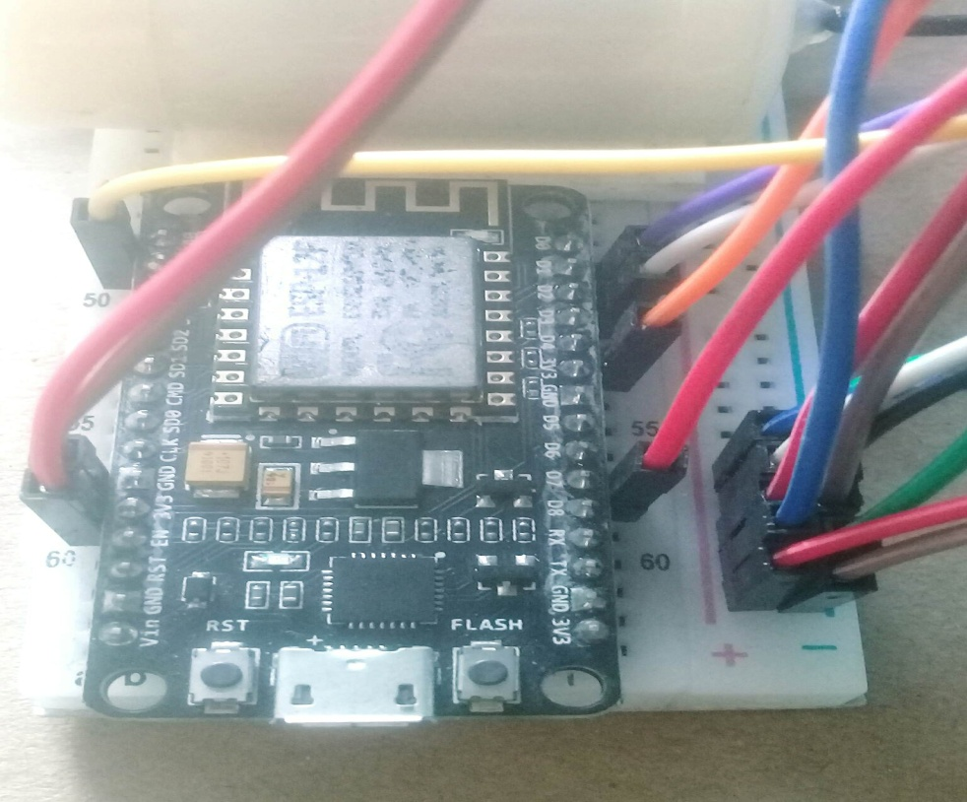

Fig 3. 9.2: Hardware Result

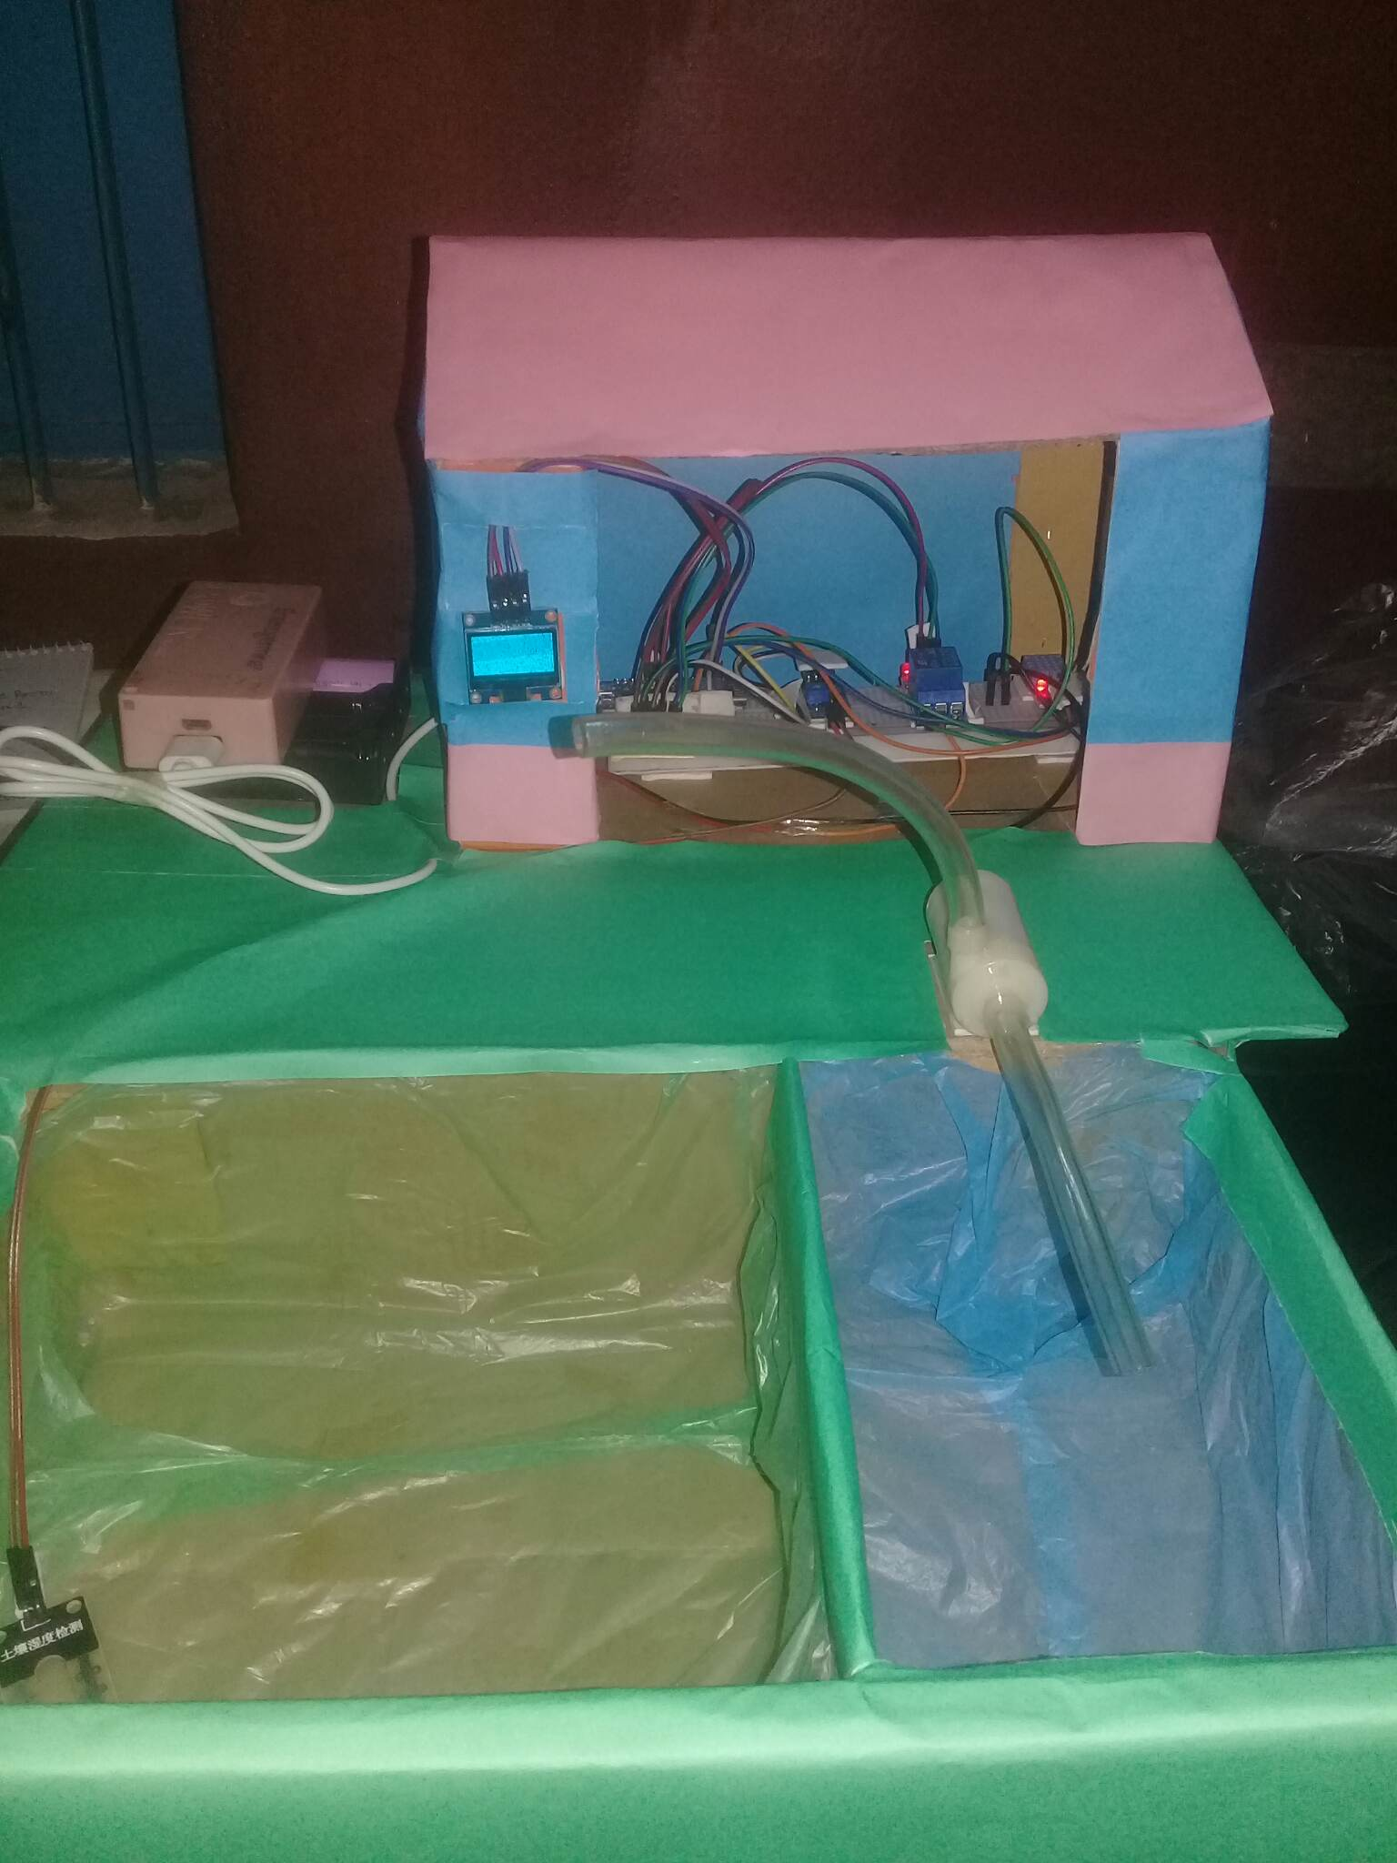

Fig 3. 9.3: Hardware Result

**3.10 Programming/Code**

1. //Include the library files
2. #include <Wire.h>
3. #include <LiquidCrystal_I2C.h>
4. #define BLYNK_PRINT Serial
5. #include <ESP8266WiFi.h>
6. #include <BlynkSimpleEsp8266.h>
7. #include <DHT.h>
8. #include <OneWire.h>
9. #include <DallasTemperature.h>
11. //Initialize the LCD display
13. LiquidCrystal_I2C lcd(0x27, 16, 2);

16. char auth[] = "ua_9QCWSnw5lY_RSqq8h4x-qFLSNXxpd"; //Enter your Blynk Auth token
17. char ssid[] = "IOT"; //Enter your WIFI SSID
18. char pass[] = "123456789"; //Enter your WIFI Password
20. OneWire oneWire(D7); // digital D7 pin DS18B20 sensor
21. DallasTemperature sensors(&oneWire);
22. DHT dht(D4, DHT11);//(DHT sensor pin,sensor type) D4 DHT11 Temperature Sensor
23. BlynkTimer timer;
25. //Define component pins
26. #define soil A0 //A0 Soil Moisture Sensor
28. int relay1State = LOW;
29. int relay2State = LOW;
31. #define RELAY_PIN_1 D3 //D3 Relay for Water pump
32. #define RELAY_PIN_2 D6 //D6 Relay 2 for LED
33. #define VPIN_BUTTON_1 V12
34. #define VPIN_BUTTON_2 V13
36. float temp = 0;
38. void setup() {
39. Serial.begin(115200);
41. lcd.init();
42. lcd.backlight();
44. pinMode(RELAY_PIN_1, OUTPUT);
45. pinMode(RELAY_PIN_2, OUTPUT);
46. digitalWrite(RELAY_PIN_1, LOW);
47. digitalWrite(RELAY_PIN_2, LOW);

50. Blynk.begin(auth, ssid, pass, "blynk.cloud", 80);
51. sensors.begin();
52. dht.begin();
54. lcd.setCursor(0, 0);
55. lcd.print(" IOT Smart Agri. ");
56. for (int a = 5; a <= 10; a++) {
57. lcd.setCursor(a, 1);
58. lcd.print(".");
59. delay(1000);
60. }
61. lcd.clear();
62. //Call the function
63. timer.setInterval(100L, soilMoistureSensor);
64. timer.setInterval(100L, DHT11sensor);
65. timer.setInterval(1000L, sendTemps);
66. }
68. //Get the DHT11 sensor values
69. void DHT11sensor() {
70. float h = dht.readHumidity();
71. float t = dht.readTemperature();
73. if (isnan(h) || isnan(t)) {
74. Serial.println("Failed to read from DHT sensor!");
75. return;
76. }
78. Blynk.virtualWrite(V0, t);
79. Blynk.virtualWrite(V1, h);
81. lcd.setCursor(0, 0);
82. lcd.print("T:");
83. lcd.print(t);
85. lcd.setCursor(8, 0);
86. lcd.print("H:");
87. lcd.print(h);
89. }
91. //Get the soil moisture values
92. void soilMoistureSensor() {
93. int value = analogRead(soil);
94. value = map(value, 0, 1024, 0, 100);
95. value = (value - 100) * -1;
97. Blynk.virtualWrite(V3, value);
98. lcd.setCursor(0, 1);
99. lcd.print("SM:");
100. lcd.print(value);
102. }

105. //Get the soil temperature
106. void sendTemps()
107. {
108. sensors.requestTemperatures();
109. temp = sensors.getTempCByIndex(0);
110. Serial.println(String("Sıcaklik=")+temp+ String(" C"));
111. Blynk.virtualWrite(V10, temp);
112. lcd.setCursor(7, 1);
113. lcd.print("ST:");
114. lcd.print(temp);
115. lcd.print(" ");
116. }
118. BLYNK_CONNECTED() {
119. // Request the latest state from the server
120. Blynk.syncVirtual(VPIN_BUTTON_1);
121. Blynk.syncVirtual(VPIN_BUTTON_2);
122. }
124. BLYNK_WRITE(VPIN_BUTTON_1) {
125. relay1State = param.asInt();
126. digitalWrite(RELAY_PIN_1, relay1State);
127. }
129. BLYNK_WRITE(VPIN_BUTTON_2) {
130. relay2State = param.asInt();
131. digitalWrite(RELAY_PIN_2, relay2State);
132. }
134. void loop() {
136. Blynk.run();//Run the Blynk library
137. timer.run();//Run the Blynk timer
139. }

CHAPTER 4

RESULTS AND DISCUSSION

**4.1 Result and Discussion**

The main aim of this project is to implement the modern technology in required fields like agriculture. Using IoT technology in agriculture, this system makes agriculture monitoring easy. The benefits as mentioned like water saving and labor saving are required the maximum in current agricultural state of affairs. The measured and monitored parameters like temperature, humidity and soil moisture, soil temperature, also led and water pump button are shown in respectively Fig 4.1.1: Temperature, Fig 4.1.2: humidity, Fig 4.1.3: Soil Moisture, Fig 4.1.4: Soil Temperature and Fig 4.1.5: Water pump and LED button. And we are also see the same value in the LCD display.

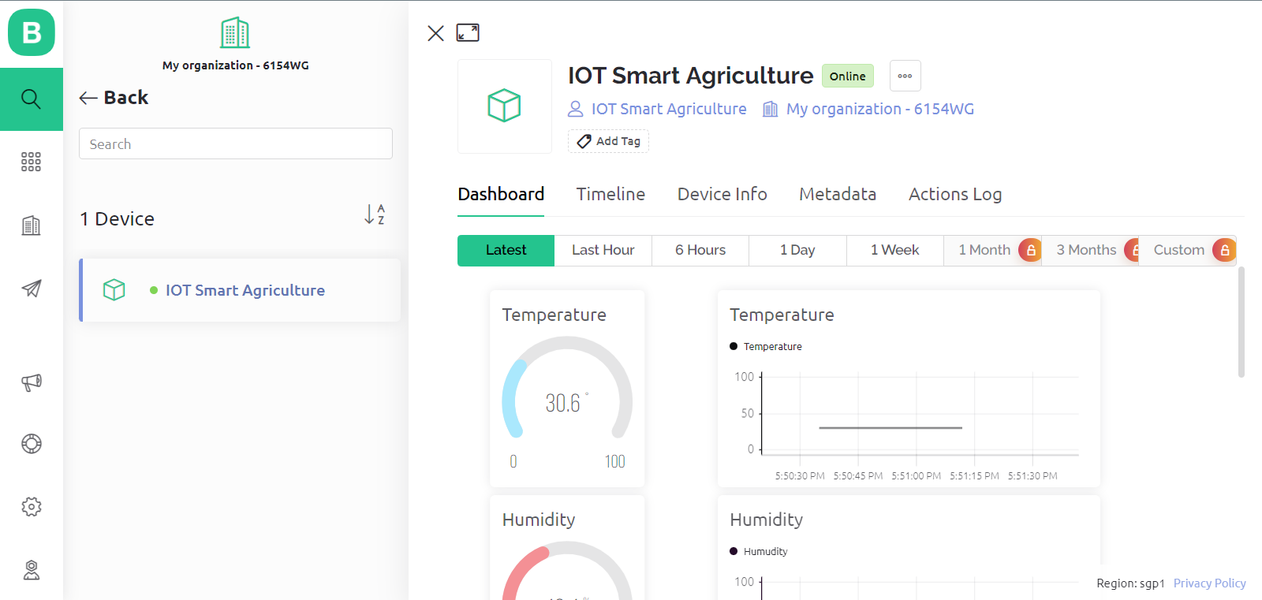

Fig 4.1.1: Temperature Result

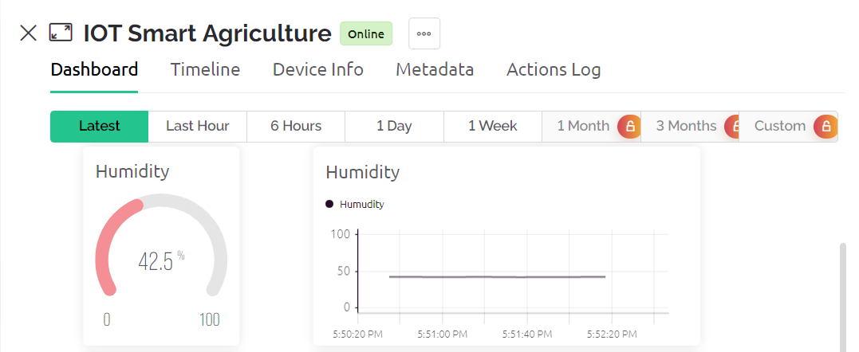

Fig 4.1.2: Humidity Result

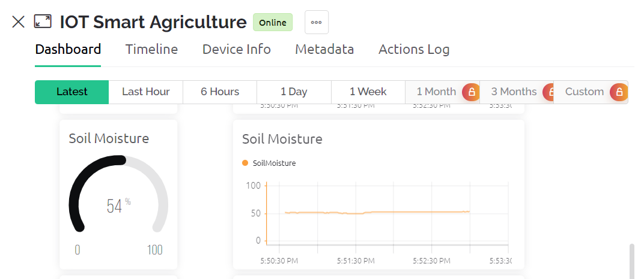

Fig 4.1.3: Soil Moisture Result

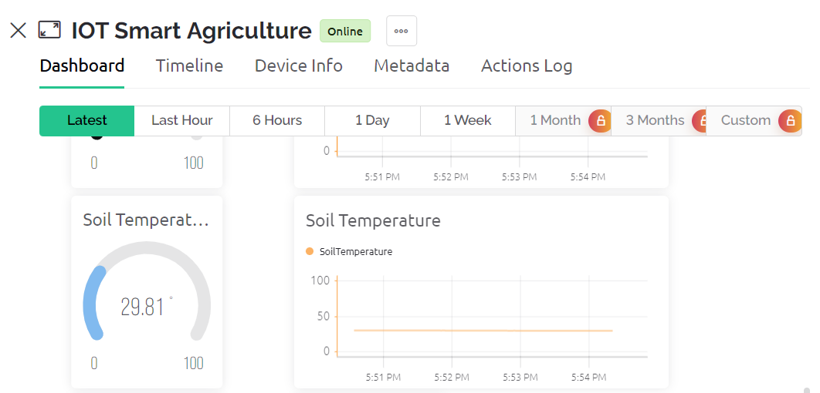

Fig 4.1.4: Soil Temperature



Fig 4.1.5: Water Pump and LED Button

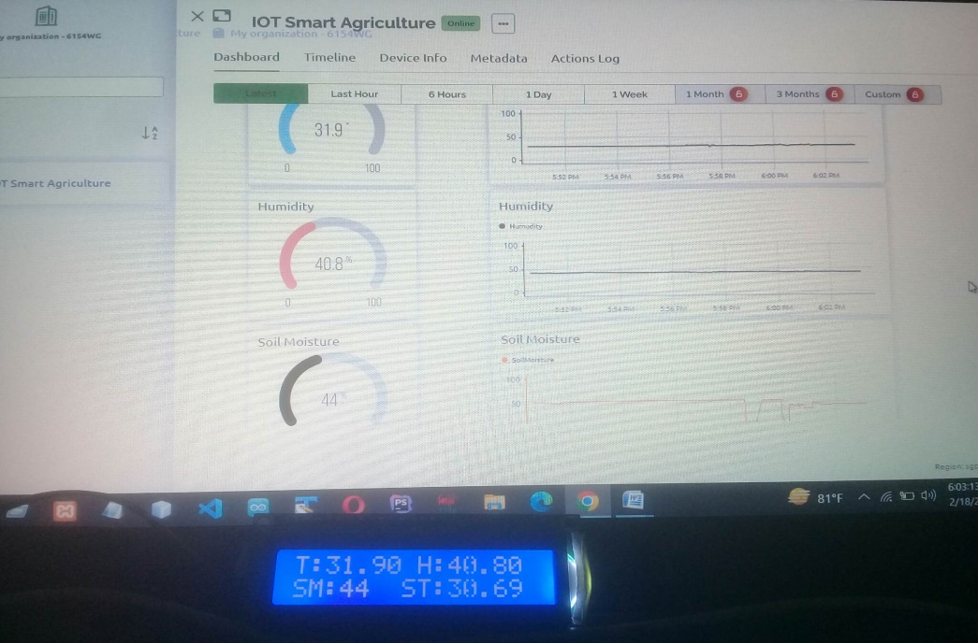

Fig 4.1.6: Value shows on display

**4.2 Budget**

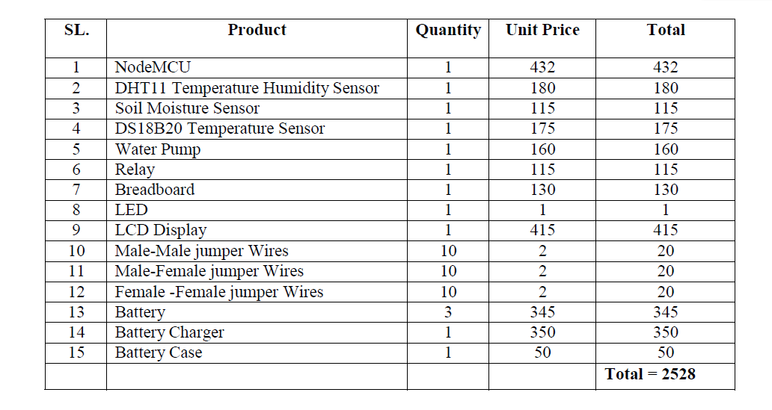

Table 4.2:Budget

CHAPTER 5

CONCLUSION AND RECOMMENDATIONS

**5.1 Conclusion and Recommendations**

IoT will help to enhance smart farming. Using IoT the system can predict the soil moisture level and humidity so that the irrigation system can be monitored and controlled. All observations and experimental tests prove that this project is a complete solution to farming activities and irrigation problems. Implementation of such a system in the farming can definitely help to minimizes human efforts and improve the yield of the crops and overall production. IoT based Smart Agriculture Monitoring System for Live Temperature, Humidity, Soil Moisture, Soil Temperature, LED and Water Pump has been proposed using NodeMCU and Cloud Computing .The System has high efficiency and accuracy in fetching the live data of temperature, humidity soil moisture and soil temperature. So all observations and experimental tests prove that this project is a complete solution to farming activities and irrigation problems. Implementation of such a system in the farming can definitely help to minimizes human efforts and improve the yield of the crops and overall production.

**5.2 Future Work**

Future work would be focused more on increasing sensors on this system to fetch more data. For future developments it can be enhanced by developing this system for large acres of land. Also the system can be integrated to check the quality of the soil (NPK) and the growth of crop in each soil. The project has vast scope in developing the system and making it more users friendly and the additional features of the system like: By installing a webcam in the system, photos of the crops can be captured and the data can be sent to database.

**5.3 Limitation**

* The system is completely dependent on data.
* This system needs internet connection.
* Also need power supply.

**References**

[1] NikeshGondchawar, Dr. R.S.Kawitkar, “IoT Based Smart Agriculture”, International Journal of Advanced Research in Computer and Communication Engineering (IJARCCE), Vol.5, Issue 6, June 2016.

[2] S. R. Nandurkar, V. R. Thool, R. C. Thool, “Design and Development of Precision Agriculture System Using Wireless Sensor Network”, IEEE International Conference on Automation, Control, Energy andSystems (ACES), 2014.

[3] Dr.N.Suma, Sandra Rhea Samson,S.Saranya,G.Shanmugapriya,R.Subhashr, “IOT Based Smart Agriculture Monitoring System”, International Journal on Recent and Innovation Trends in Computing and Communication(IJRITCC), Vol: 5, Issue: 2,2017.

[4] HarikaPendyala, Ganesh Kumar Rodda, AnoojaMamidi, MadhaviVangala,SathyamBonala, Keerti Kumar Korlapati, “IOT Based Smart Agriculture Monitoring System”, International Journal of Scientific Engineering and Research (IJSER), Vol:9, Issue:7, July 2021.

[5] M. MANOJ VENKATA SAI, K. SUBBA RAO, N. VAMSI KRISHNA, M. VASANTHA LAKSHMI, “ Iot Based Smart Agriculture” ICONIC RESEARCH AND ENGINEERING JOURNALS (IRE), Vol:1, Issue:8 , FEB 2018.

[6] Swaraj C M, K M Sowmyashree, “IOT based Smart Agriculture Monitoring and Irrigation System”, ICONIC RESEARCH AND ENGINEERING JOURNALS (IJSER), Vol:8, Issue:14 ,2020.

[7] YASIR FAHIM , Mrs. Tania Sarkar, “A Mini Project Report On IoT-Based SMART FARMING SYSTEM”, December 2018